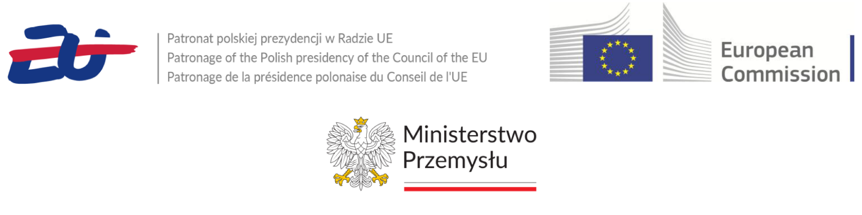

European Coal in Transition: “from an industrial legend to cutting-edge research for the future”  
Jastrzębie-Zdrój, Poland, 15 May 2025 (and online)

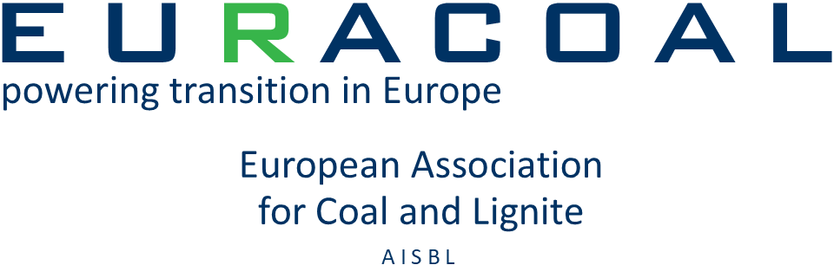 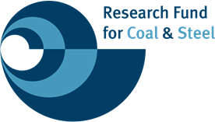

Welcome to this high-level event co-organised by EURACOAL and the European Research Executive Agency and kindly hosted by Jastrzębska Spółka Węglowa S.A. at Carbonarium, 50 kilometres southwest of Katowice. The goal is to highlight the impact of projects supported by the EU Research Fund for Coal and Steel (RFCS) on the just transition of Europe’s coal regions and raise awareness of the fund’s vital role in the regional transition towards the objectives of the European Green Deal.

This workshop will showcase several RFCS-funded projects, with a focus on methane emission abatement and the repurposing of coal mines.

The RFCS’s role in supporting implementation of the EU Methane Regulation of 2024 under the Fit‑for‑55 policy package will be presented in detail given its potential to help reduce greenhouse gas emissions. Another panel will discuss how RFCS projects complement the Just Transition Mechanism with land restoration, repurposing of mining infrastructure and creating opportunities for new green jobs.

Participants will also be informed about the opportunities for future projects under the upcoming “Big-Ticket” and annual calls of the RFCS Research Programme for 2025-2026. Insights from the European Commission will be shared on EU priorities for coal-related research and the importance of aligning project proposals with the European Green Deal’s objective of achieving a climate-neutral EU by 2050.

Project teams will share their experiences on managing successful projects, highlighting their ambitious goals and the results of their current work. The event will feature Q&A sessions and networking opportunities for those interested in current and future RFCS projects.

Agenda

08.30 Registration

# Keynote speeches (with PL<>EN interpretation)

09.30 Mr. Ryszard Janta, President of Jastrzębska Spółka Węglowa S.A. (JSW)

09.40 Mr. Leszek Pietraszek, Vice-Marshal of the Silesian Voivodeship

09.50 Mr. Marc Lemaître, Director-General, European Commission DG Research & Innovation

10.00 Mr. Marc Tachelet, Director of the European Research Executive Agency

10.10 Ms. Alicja Krzemień, President of EURACOAL

10.20-11.05 Coffee break

# Session 1 – Methane mitigation strategies at EU coal mines

11.05 “Reduction of methane emissions from post mining goafs to minimise their inflow into Ventilation Air Methane”

[REM](https://ec.europa.eu/info/funding-tenders/opportunities/portal/screen/opportunities/projects-details/43252449/101099061/RFCS2027) (101099061) RFCS Big Ticket Project  
February 2023 – July 2027  
Główny Instytut Górnictwa – Państwowy Instytut Badawczy (GIG-PIB, PL), Instytut Nafty i Gazu – Państwowy Instytut Badawczy (INiG-PIB, PL), Jastrzębska Spółka Węglowa S.A. (JSW, PL), Państwowy Instytut Geologiczny – Państwowy Instytut Badawczy (PIG-PIB, PL), Universidad de Oviedo (ES), Institutul Național de Cercetare-Dezvoltare pentru Securitate Minieră și Protecție Antiexplozivă (INSEMEX Petroşani, RO)

The REM project aims to reduce methane emissions from abandoned mine methane (AMM) in post-mining goafs. It involves intelligent management of low-concentration AMM using advanced technologies, monitoring VAM emissions, and converting methane to electricity and heat. This project supports the Global Methane Pledge and aims to minimise the carbon footprint of coal mines.

REM project presented by Artur Badylak, Jastrzębska Spółka Węglowa S.A. (JSW)

“Reduction of Ventilation Air Methane Emissions in the Coal Mining Transformation Process”

[ProVAM](https://ec.europa.eu/info/funding-tenders/opportunities/portal/screen/opportunities/projects-details/43252449/101112618/RFCS2027) (101112618) RFCS Research Project  
October 2023 – September 2026  
Główny Instytut Górnictwa – Państwowy Instytut Badawczy (GIG-PIB, PL), Instytut Mechaniki Górotworu Polskiej Akademii Nauk (IMG PAN, PL), Instytut Techniki Górniczej KOMAG (PL), Instytut Inżynierii Chemicznej Polskiej Akademii Nauk (IICh PAN, PL), Universidad de Oviedo (ES), Institutul Național de Cercetare-Dezvoltare pentru Securitate Minieră și Protecție Antiexplozivă (INSEMEX Petroşani, RO), Dürr Systems AG (DE), Jastrzębska Spółka Węglowa S.A. (JSW, PL)

The ProVAM project aims to reduce Ventilation Air Methane (VAM) emissions in European underground coal mines by addressing dust load, humidity, and variable air and methane flows. The project involves major industry players and scientific units, with results to be tested in Poland’s GIG Experimental Mine “Barbara” and disseminated globally.

ProVAM project presented by Carsten Walddörfer, Dürr Systems AG and Jacek Skiba, Central Mining Institute (GIG-PIB)

11.45 Panel discussion on how RFCS projects will help implement the new Methane Regulation (EU) 2024/1787 and move the EU towards its target of reducing net greenhouse gas emissions by at least 55% by 2030 (Fit for 55)

Panellists: Dinko Raytchev, Methane strategy team, European Commission DG ENER; Piotr Litwa, President, State Mining Authority (WUG); Artur Badylak, Director of Methane Drainage Office, Jastrzębska Spółka Węglowa S.A. (JSW); Jarosław Zagórowski, Director, Central Mining Institute (GIG-PIB)

With introduction of projects recently granted: “**Methane monitoring of abandoned coal mines**” (MEMO) by Hafid Baroudi, Director, Institut national de l’environnement industriel et des risques (INERIS); and **“Methane to Hydrogen Conversion for Emission Reduction and Energy Generation**” (METH2GEN) by Renata Cicha-Szot, Head of Department of Petroleum Engineering, Oil and Gas Institute (INiG)

Moderator: Jürgen Tiedje, Head of Unit for Industrial Transformation at European Commission DG Research & Innovation

Q&A

12.45-13.45 Lunch

# 13.45 Ms. Marzena Czarnecka, Polish Minister of Industry

# Session 2 – RFCS projects on the repurposing of coal mines

13.55 “Sustainable and intelligent mine waste management towards Green Deal economy pilot and demonstration project GI-mine (Green and Intelligent mine)”

[GI-MINE](https://ec.europa.eu/info/funding-tenders/opportunities/portal/screen/opportunities/projects-details/43252449/101157792/RFCS2027) (101157792) RFCS Pilot and Demonstration Project  
July 2024 – December 2027  
Główny Instytut Górnictwa – Państwowy Instytut Badawczy (GIG-PIB, PL), Polska Grupa Górnicza S.A. (PGG, PL), Technische Universität Bergakademie Freiberg (TU Freiberg, DE), Universidad de Oviedo (ES), Uniwersytet Przyrodniczy w Poznaniu (PL), Mongolian Coal Association (MN), Digital Communications Network Global (DCN Global, EL)

The GI-mine project aims to pilot the optimisation of waste management in mining by developing circular solutions and guidelines. It focuses on sustainable management of mining waste, including soil substrate utilisation, and greenhouse heating using excess heat energy. The project supports the European Green Deal and targets dissemination in Central Europe, Southern Balkans, and Mongolia.

GI-MINE project presented by Marcin Głodniok, Central Mining Institute (GIG-PIB) (including a 2-minute video)

Her Excellency Navaan-Yundengiin Oyundari, Ambassador of Mongolia in Poland

From “RECOVERY of degraded and transformed ecosystems in coal mining-affected areas” to “Leveraging the competitive advantages of end-of-life underground coal mines to maximise the creation of green and quality jobs”

[RECOVERY](https://ec.europa.eu/info/funding-tenders/opportunities/portal/screen/opportunities/projects-details/31061225/847205/RFCS?order=DESC&pageNumber=1&pageSize=10&sortBy=title&keywords=RECOVERY&isExactMatch=false&frameworkProgramme=31061225) (847205) RFCS Research Project  
July 2019 – June 2023  
Główny Instytut Górnictwa – Państwowy Instytut Badawczy (GIG-PIB, PL), Universidad de Oviedo (ES), Humboldt-Universität zu Berlin (HU Berlin, DE), Technická univerzita Ostrava (VŠB, CZ), Hulleras del Norte S.A. (HUNOSA, ES), TAURON Wydobycie S.A. (PL), DIAMO státní podnik (DIAMO, CZ)

It contributed to the rehabilitation of coal mining-affected areas, restoration of ecosystems by evaluating ecosystem contributions to human wellbeing.

[GreenJOBS](https://ec.europa.eu/info/funding-tenders/opportunities/portal/screen/opportunities/projects-details/43252449/101057789/RFCS2027?order=DESC&pageNumber=1&pageSize=50&sortBy=title&keywords=repurposing%20end-of-life%20underground%20coal%20mines&isExactMatch=true) (101057789) RFCS Research Project  
July 2022 – December 2025  
Universidad de Oviedo (ES), Główny Instytut Górnictwa – Państwowy Instytut Badawczy (GIG-PIB, PL), Fundación Asturiana de la Energia (FAEN, ES), DMT-Gesellschaft für Lehre und Bildung mbH (DMT-LB, DE), Magellan & Barents S.L. (ES), Hulleras del Norte S.A. (HUNOSA, ES), Premogovnik Velenje d.o.o. (PV, SI), Węglokoks Kraj S.A. (PL)

The project aims to provide mining companies with two innovative business plans: a Virtual Power Plant and a Green Hydrogen, promoting sustainable local economic growth and maximising the number of green, quality jobs. Also exploring on restoration of coal mining ecosystems.

RECOVERY and GreenJOBS projects presented by Pedro Riesgo Fernández, University of Oviedo (including a 5-minute video)

“Transition Information Modelling for transition from coal exploitation to a re-vitalised post-mining land”

[TRIM4Post-Mining](https://ec.europa.eu/info/funding-tenders/opportunities/portal/screen/opportunities/projects-details/31061225/899278/RFCS?order=DESC&pageNumber=1&pageSize=10&sortBy=title&keywords=TRIM&isExactMatch=false&frameworkProgramme=31061225) (899278) RFCS Research Project  
August 2020 to July 2023  
Technische Universität Bergakademie Freiberg (TU Freiberg, DE), Technische Universiteit Delft (TU Delft, NL), Mitteldeutsche Braunkohlengesellschaft mbH (MIBRAG, DE), Spectral Industries B.V. (NL), Beak Consultants GmbH (DE), DMT-Gesellschaft für Lehre und Bildung mbH (DMT-LB, DE), Royal Eijkelkamp B.V. (NL)

Development of an advanced information system to transform coal mining sites into landscapes for agriculture and industry while recovering energy and materials from waste. Using a high-resolution database and multi-sensor monitoring, the project tracks changes in coal waste dumps, identifies contamination risks, and forecasts impacts.

TRIM4Post-Mining project presented by Jörg Benndorf, TU Bergakademie Freiberg

14.30 Panel discussion on the repurposing of closed coal mines, on what has been achieved so far, and on what still needs to be done. Panellists will explore the impacts on jobs and what ambitions there are for new, green jobs.

Panellists: Robert Pollock, Senior Advisor to the EU Coal Regions in Transition Initiative; Grzegorz Sikorski, Director, Silesian Voivodeship Labour Office in Katowice; Jarosław Wieszołek, President of the Board, Spółka Restrukturyzacji Kopalń S.A. (SRK); Magdalena Chawuła, Programme Director – People, Cities, Regions, Forum Energii; Małgorzata Staś, Director, Department of Development and Regional Transformation, Marshal’s Office of the Silesian Voivodeship in Poland

With introduction of projects recently granted: “**Raising awareness of small local communities in the process of coal mining transition**” (RAISING) by Julia Haske, Head of Land Use & Transition, Research Center of Post-Mining, Technische Hochschule Georg Agricola, Bochum; and **“From COal to Farm”** (COFA) by Barbara Rogosz, Acting Director, Poltegor Institute

Moderator: Sebastiano Fumero, Head of Unit for Future Low Emission Industries at the European Research Executive Agency

Q&A

# Future opportunities, conclusions and closing remarks

15.30 *Next steps for the RFCS*  
Jürgen Tiedje, Head of Unit for Industrial Transformation at European Commission DG Research & Innovation

15.45 *The RFCS Annual and Big-Ticket Calls 2025-2026 – opportunities for project proposers,* Sebastiano Fumero, Head of Unit for Future Low Emission Industries at the European Research Executive Agency

15.55 Concluding remarks by EURACOAL Secretary-General Brian Ricketts

16.10 Networking drinks